EXERCISE-3

Image of the pallet frame
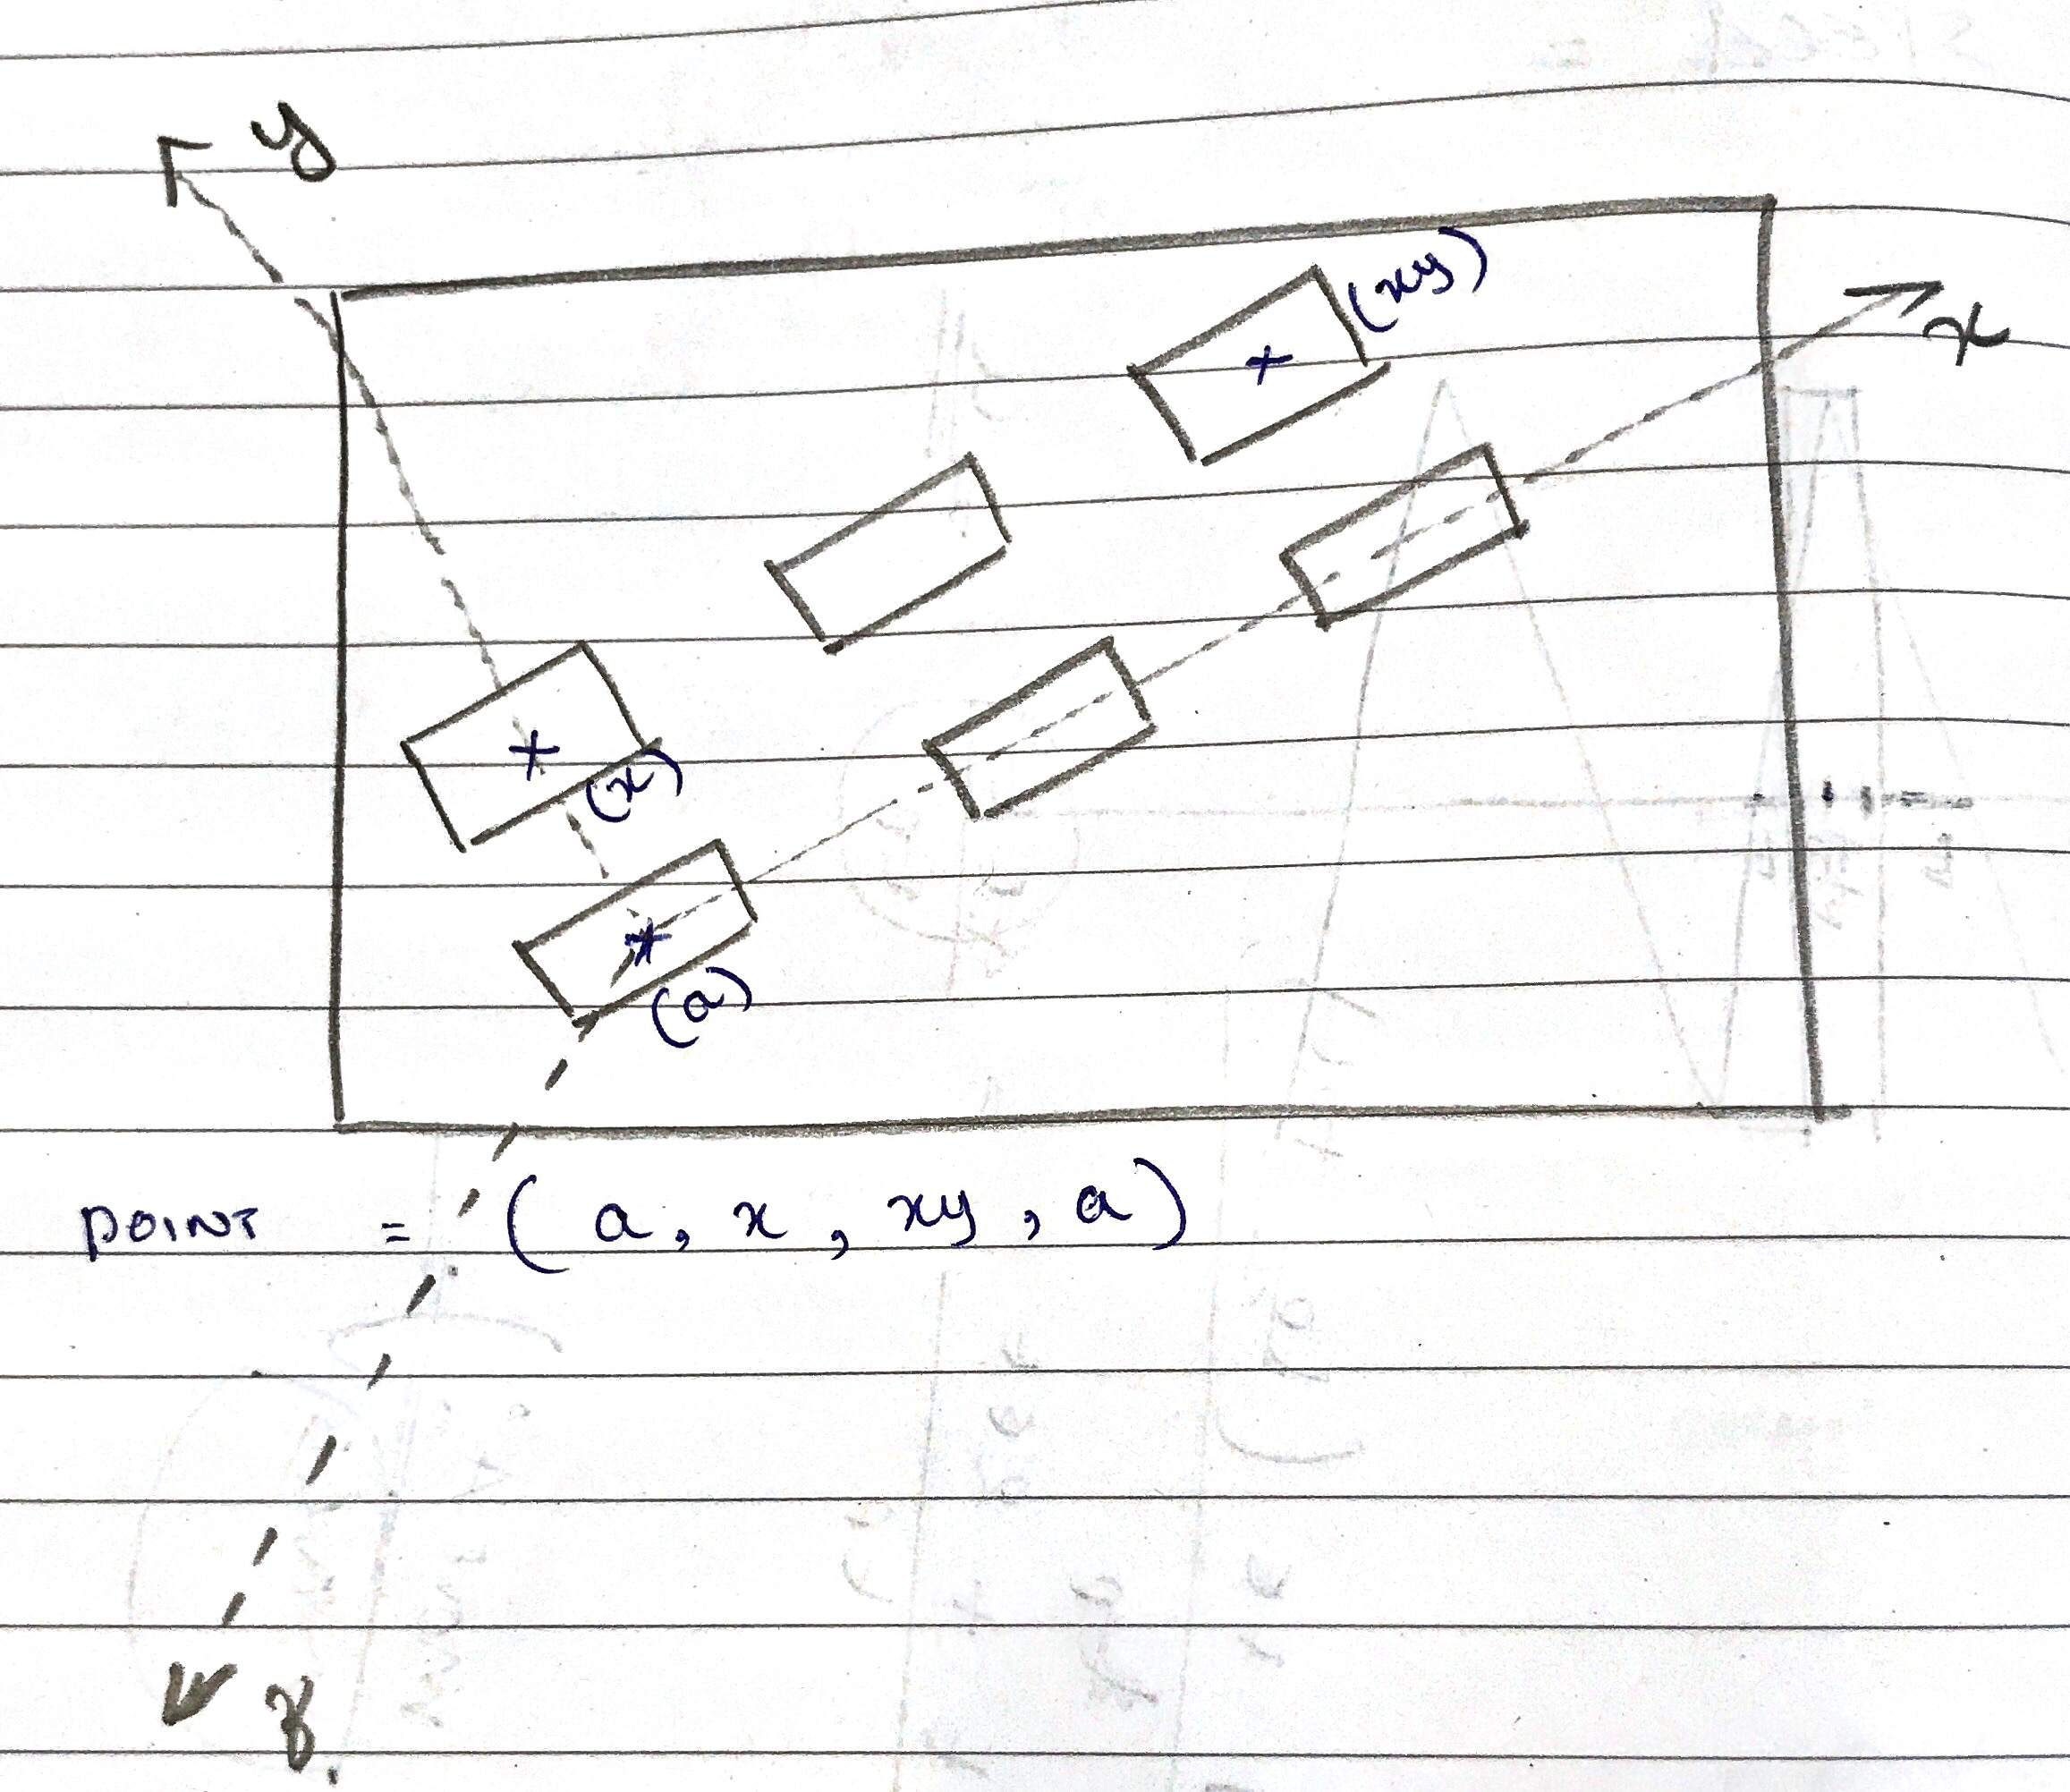
Instructions

->set pallet = frame(a,x,xy,a) – To define the frame named pallet with a and x define the direction of x axis.Here a ,x,xy define the xy plane and xy orients y. Here a is the origin of the frame

->set object=shift(pallet by i*82,j*59,0) – To shift along the pallete inorder to reach and pick different parts in the pallet.Here it is shifted along x and y

->set drop =shift(null by 0,0,15)- To shift along the z axis in the drop location

